Click anywhere on this page to go to the Form.

Employee Communication Form
Instructions / Process

- Fill out Employee Communication Form.

- Your name is required so that members of the appropriate organization may contact you for more information if necessary and follow up to inform you of the progress of your issue.

- If you wish for H.R. to remove your name before forwarding the issue to the appropriate group/person for further consideration, please check the box below your name. These names will be kept confidential by H.R. If it is necessary for H.R. to disclose your name, you will first be contacted for approval.

- Send Form to Human Resources

- H.R. will forward the form to the appropriate group or person

(depending upon the scope of the issue).

- H.R. will communicate to you when the item was received and the status of your issue.

(Note: Your Name is required for this to happen).

- If item is sent to a committee or team, that group will take the appropriate action.

- Those items, which are determined to be departmental issues, will be sent to the appropriate

department director for further consideration.

- A member of the appropriate group will contact you reference the status of your issue.

Click anywhere on this page to go to the Form.

EMPLOYEE COMMUNICATION FORM
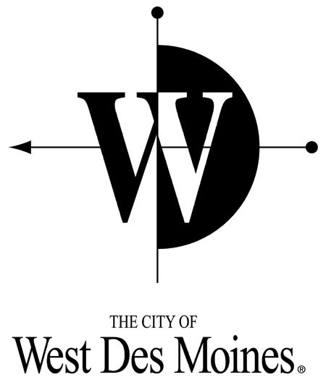
Our mission is to service the people of West Des Moines honestly and effectively. Through a variety of services, we strive to provide the quality of life desired by the community.
We, the employees of the City of West Des Moines, through Teamwork and Cooperation, are committed to provide the highest Quality of Service with Honesty and Integrity to the community we serve.

We are seeking ideas/concerns from each City employee interested in making West Des Moines the best place to work and serve its citizens.

Name: Date: Department:

Check here to have your name removed from form before HR forwards to the appropriate group or person for further consideration.

Description (Issue, Concern or Idea):

Possible Causes (What is the need for change?):

Possible Solution/ Suggested ways to improve:

Employee(s) who may be used as a resource/expert in working on a solution to this issue:

Suggested Route (who should consider this idea):

Department Head Department Quality Council City Wide Quality Team Employee Relations Committee

City Manager Human Resources Safety Committee Unknown Other

For Office Use Only
ACTION TAKEN:

